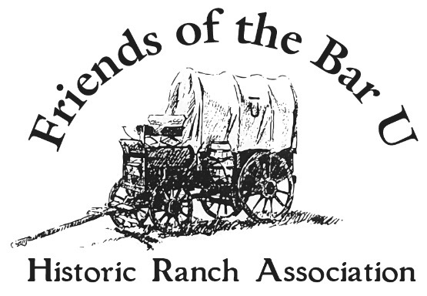
Brand Board Application

CATTLE OR HORSE______________________

BRAND POSITION ______________________

DRAW BRAND AS REGISTERED

DATE BRAND WAS REGISTERED: ______________________________________________

NAME OF CURRENT OWNER: _________________________________________________

MAILING ADDRESS: _________________________________________________________

CITY/TOWN/PROVINCE: _____________________________________________________

POSTAL CODE: ___________________________ TELEPHONE: ______________________

EMAIL : _________________________________

IF BRAND IS IN HONOUR OF SOMEONE OR IN MEMORY OF SOMEONE DECEASED, PLEASE INDICATE BELOW THE NAME TO BE USED:

(INDICATE WHETHER: _______IN HONOUR - OR- _______ IN MEMORY)

*************************************************************************************
$100.00 FEE – TO BE PAID TO “THE FRIENDS OF THE BAR U HISTORIC RANCH ASSOCIATION”

CASH _____________ CHEQUE #________________ DATE RECEIVED_____________________________
Cont. on pg. 2…

Brand Board Application pg. 2
HISTORY OF BRAND
OWNER NAME_______________

Please mail this application with your cheque to the address below:

